Android
Android is a software package and linux based operating system for mobile devices such as tablet computers and smartphones. Android was developed by the Open Handset Alliance (OHA), which is led by Google. The Open Handset Alliance (OHA) is a consortium of multiple companies like Samsung, Sony, Intel and many more to provide services and deploy handsets using the android platform. The goal of android project is to create a successful real-world product that improves the mobile experience for end users. Android becomes an absolute set of software for all devices like tablets, wearables, set-top boxes, smart TVs, notebooks, etc.

Android Features
Android is a powerful open-source operating system which provides a lot of great features, those are
- It’s open-source and we can customize the OS based on our requirements.
- Android supports connectivity for GSM, CDMA, WIFI, NFC, Bluetooth, etc. for telephony or data transfer. It will allow us to make or receive a calls / SMS messages and we can send or retrieve data across mobile networks
- By using WIFI technology we can pair with other devices while playing games or using other applications.
- Android has multiple APIs to support location-based services such as GPS
- We can perform all data storage related activities by using lightweight database SQLite.
- It has a wide range of media supports like AVI, MKV, FLV, MPEG4, etc. to play or record a variety of audio/video and having a different image format like JPEG, PNG, GIF, BMP, MP3, etc.
- It has extensive support for multimedia hardware control to perform playback or recording using camera and microphone
- It has an integrated open-source WebKit layout based web browser to support HTML5, CSS3
- It supports a multi-tasking, we can move from one task window to another and multiple applications can run simultaneously.
- It will give a chance to reuse the application components and the replacement of native applications.
- We can access the hardware components like Camera, GPS, and Accelerometer
- It has support for virtual reality or 2D/3D Graphics.

Android History
Initially, Google launched the first version of Android platform on Nov 5, 2007, from that onwards Google released a lot of android versions under a codename based on desserts, such as Apple Pie, Banana Bread, Cupcake, Donut, Éclair, Froyo, Gingerbread, Jellybeans, Kitkat, Lollipop, marshmallow, etc. and made a lot of changes and additions to the android platform.

- The following table lists the different version details of android which is released by Google from 2007 to till date.

Release Date | Version | API Level | Version Name
September 23, 2008 | Android 1.0 | 1 | Apple Pie
February 9, 2009 | Android 1.1 | 2 | Banana Bread
April 30, 2009 | Android 1.5 | 3 | Cupcake
September 15, 2009 | Android 1.6 | 4 | Donut
October 26, 2009 | Android 2.0 | 5 | Eclair
December 3, 2009 | Android 2.0.1 | 6
January 12, 2009 | Android 2.1 | 7
May 20, 2010 | Android 2.2 | 8 | Froyo
January 18, 2011 | Android 2.2.1 | 8
January 22, 2011 | Android 2.2.2 | 8
November 21, 2011 | Android 2.2.3 | 8
December 6, 2010 | Android 2.3 | 9 | Gingerbread
February 9, 2011 | Android 2.3.1 | 9
July 25, 2011 | Android 2.3.3 | 10
September 2, 2011 | Android 2.3.4 | 10
February 22, 2011 | Android 3.0.x | 11 | Honeycomb
May 10, 2011 | Android 3.1.x | 12
July 15, 2011 | Android 3.2.x | 13
October 18,2011 | Android 4.0 | 14 | Ice Cream Sandwich
October 19, 2011 | Android 4.0.1 | 14
November 28, 2011 | Android 4.0.2 | 14
December 16, 2011 | Android 4.0.3 | 15
February 4, 2012 | Android 4.0.4 | 15
July 9, 2012 | Android 4.1 | 16 | Jelly Bean
July 23, 2012 | Android 4.1.1 | 16
October 9, 2012 | Android 4.1.2 | 16
November 13, 2012 | Android 4.2 | 17
November 27, 2012 | Android 4.2.1 | 17
February 11, 2013 | Android 4.2.2 | 17
July 24, 2013 | Android 4.3 | 18
October 31, 2013 | Android 4.4 | 19 | Kitkat
June 23, 2014 | Android 4.4.1, 4.4.2, 4.4.3, 4.4.4 | 19
October 17, 2014 | Android 5.0 | 21 | Lollipop
March 09, 2015 | Android 5.1 | 22
October 5, 2015 | Android 6.0 | 23 | Marshmallow
December 7, 2015 | Android 6.0.1 | 23
August 22, 2016 | Android 7.0 | 24 | Nougat
October 4, 2016 | Android 7.1 | 25
August 21, 2017 | Android 8.0 | 26 | Oreo
December 5, 2017 | Android 8.1 | 27
August 6, 2018 | Android 9.0 | 28 | Pie
September 3, 2019 | Android 10.0 | 29 | Android 10
September 8, 2020 | Android 11 | 30 | Android 11

- For each version, Google has made a lot of changes and introduced a lot of new features due to the usage of android in the mobile market increased drastically.

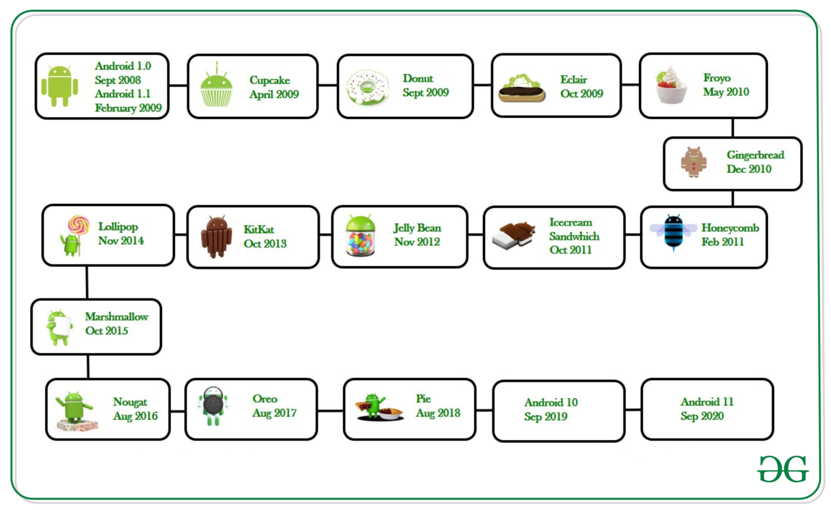

Programming Languages used in Developing Android Applications
- Java
- Kotlin
Developing the Android Application using Kotlin is preferred by Google, as Kotlin is made an official language for Android Development, which is developed and maintained by JetBrains. Previously before the Java is considered the official language for Android Development. Kotlin is made official for Android Development in Google I/O 2017.

Advantages of Android Development
- The Android is an open-source Operating system and hence possesses a vast community for support.
- The design of the Android Application has guidelines from Google, which becomes easier for developers to produce more intuitive user applications.
- Fragmentation gives more power to Android Applications. This means the application can run two activities on a single screen.
- Releasing the Android application in the Google play store is easier when it is compared to other platforms.

Disadvantages of Android Development
- Fragmentation provides a very intuitive approach for user experience but it has some drawbacks, where the development team needs time to adjust with the various screen sizes of mobile smartphones that are now available in the market and invoke the particular features in the application.
- The Android devices might vary broadly. So the testing of the application becomes more difficult.
- As the development and testing consume more time, the cost of the application may increase, depending on the application’s complexity and features.

